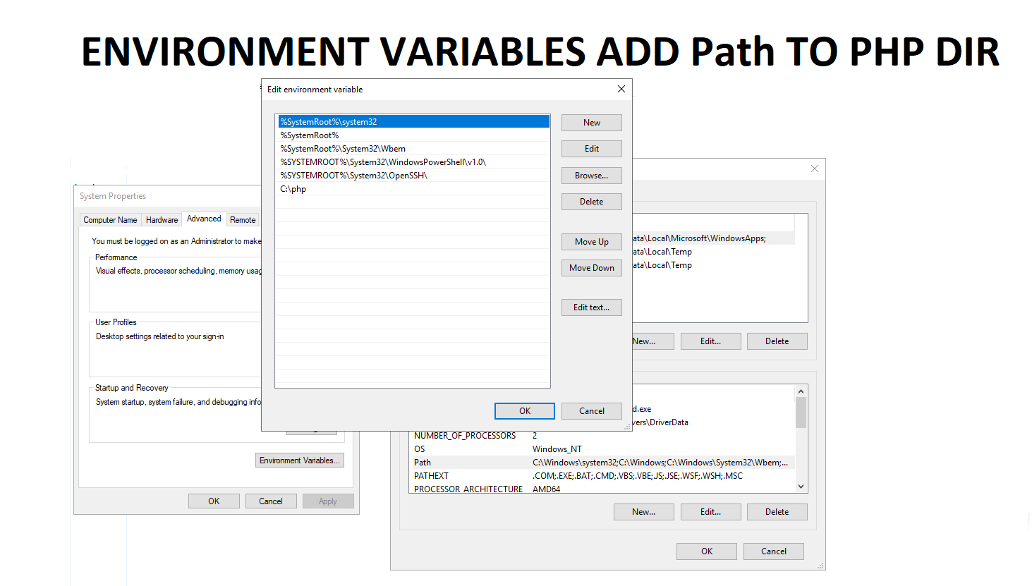

In PHP :
Rename php.ini-production to : php.ini

Changes in php.ini to be done :
- uncomment the follow : cgi.fix_pathinfo=1
- uncomment and set value to zero : cgi.force_redirect = 0
- uncomment : fastcgi.impersonate = 1
- uncomment : fastcgi.logging = 0
- uncomment : extension=mysqli
- uncomment : extension=pdo_mysql

Create User :
php_user
P@sswordP@ssw0rd
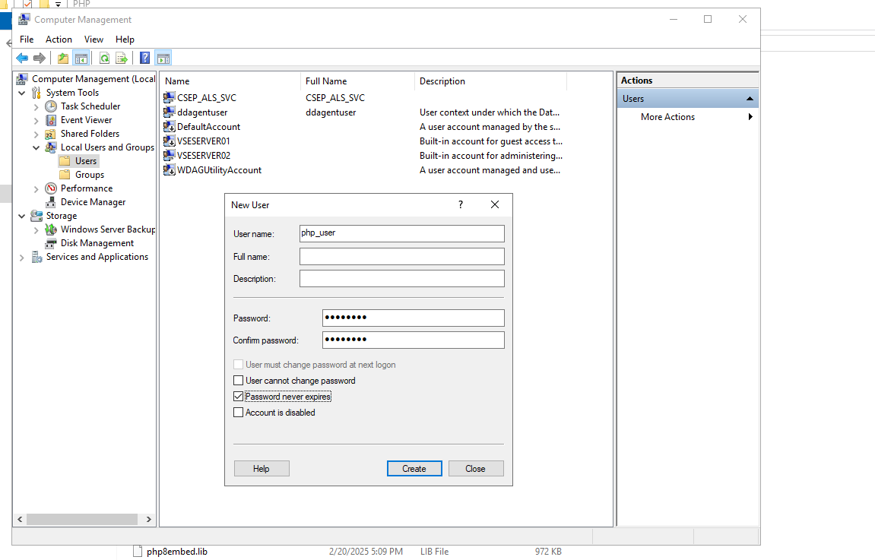
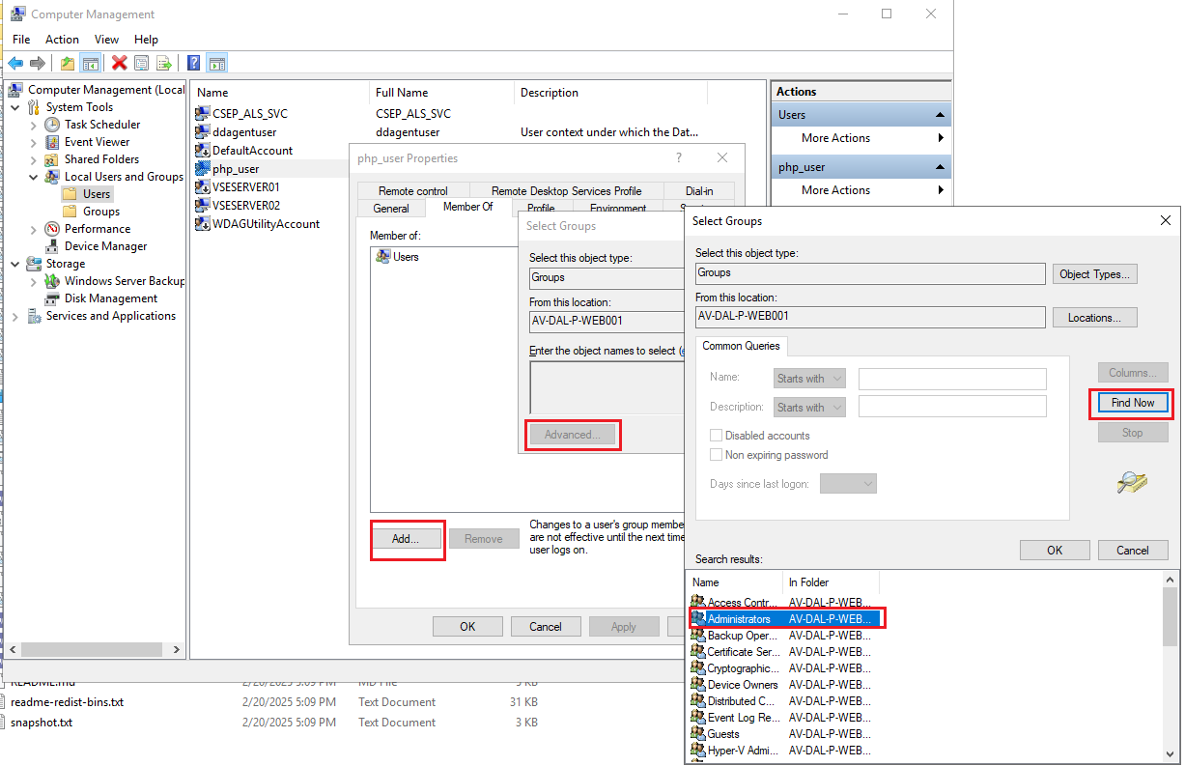
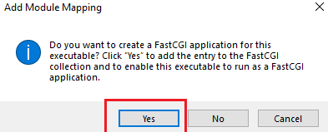
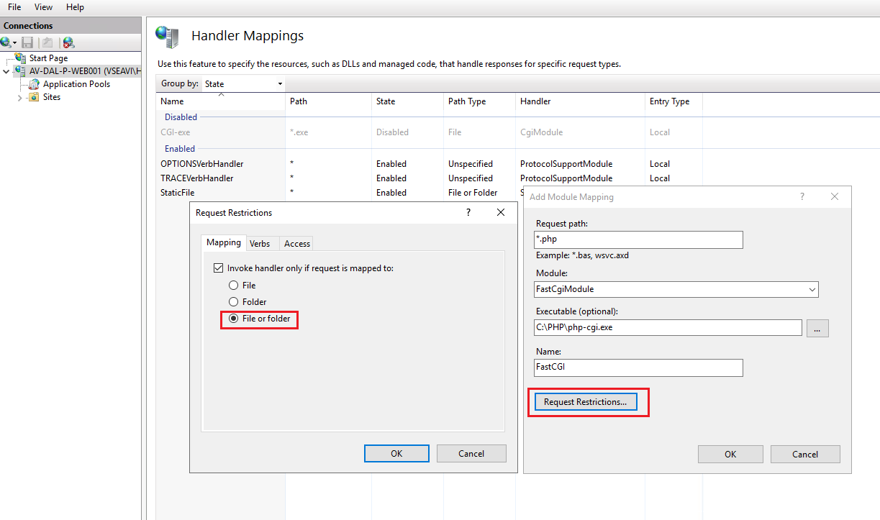

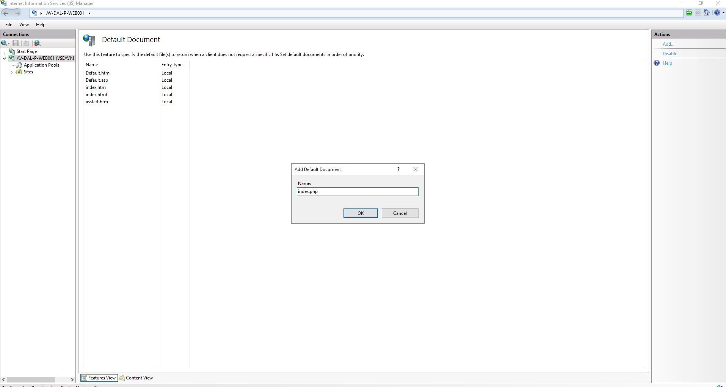
PHP_FCGI_MAX_REQUEST
1000
