CREATE VPN SERVER IN WINDOWS

1.View Network Connections
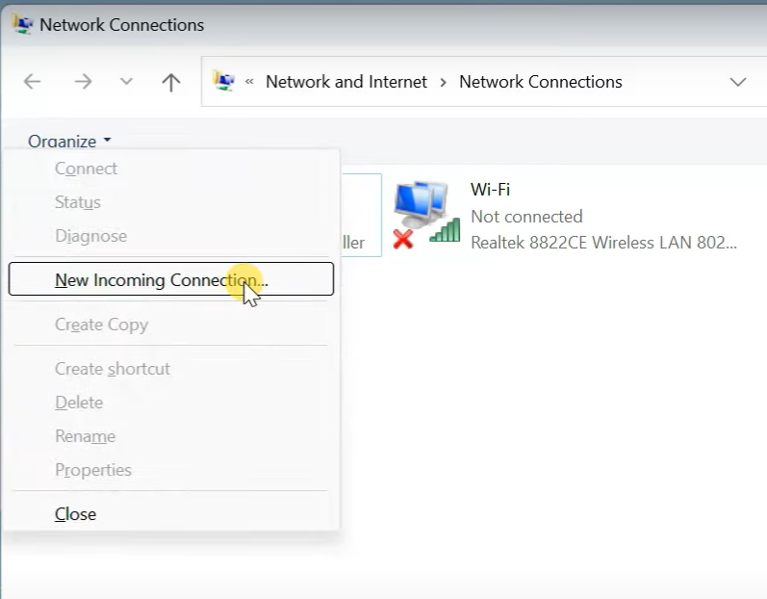
2.Create Username for better security purpose to be only for vpn
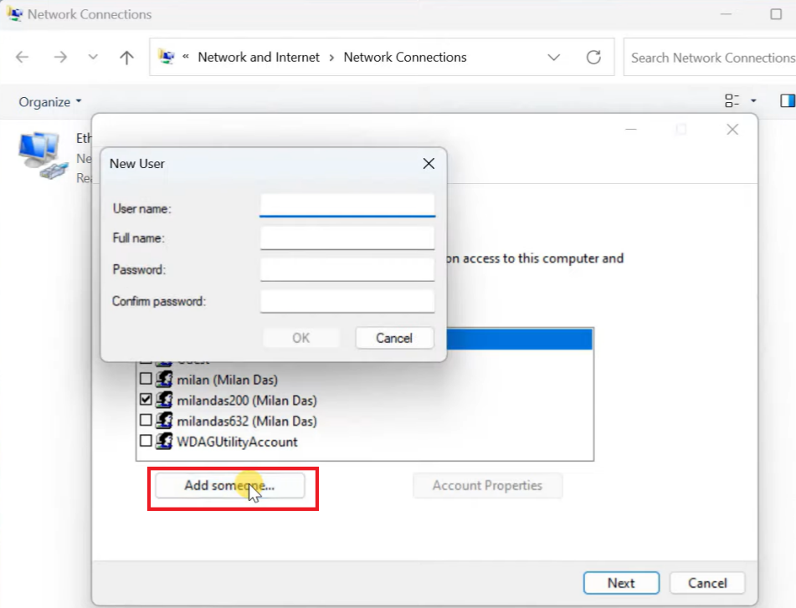

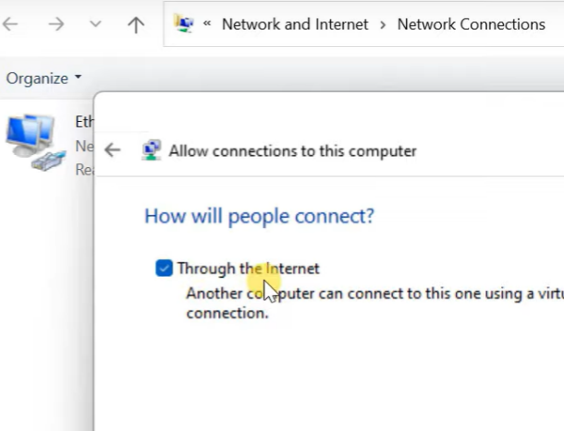

3- Create DHCP RANGE THAT DOESN’T MATCH WITH THE ROUTER TO AVOID IP CONFLICT like
192.168.1.230 to 192.168.1.235

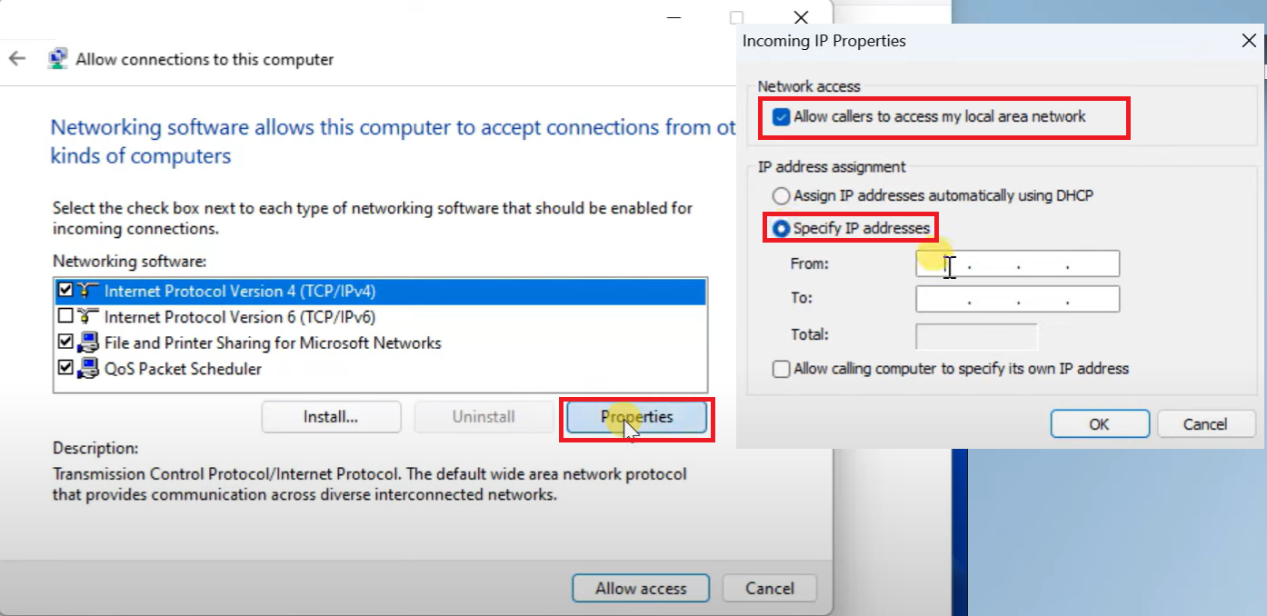
Then click Allow access

Allow Windows Firewall to allow external connections :
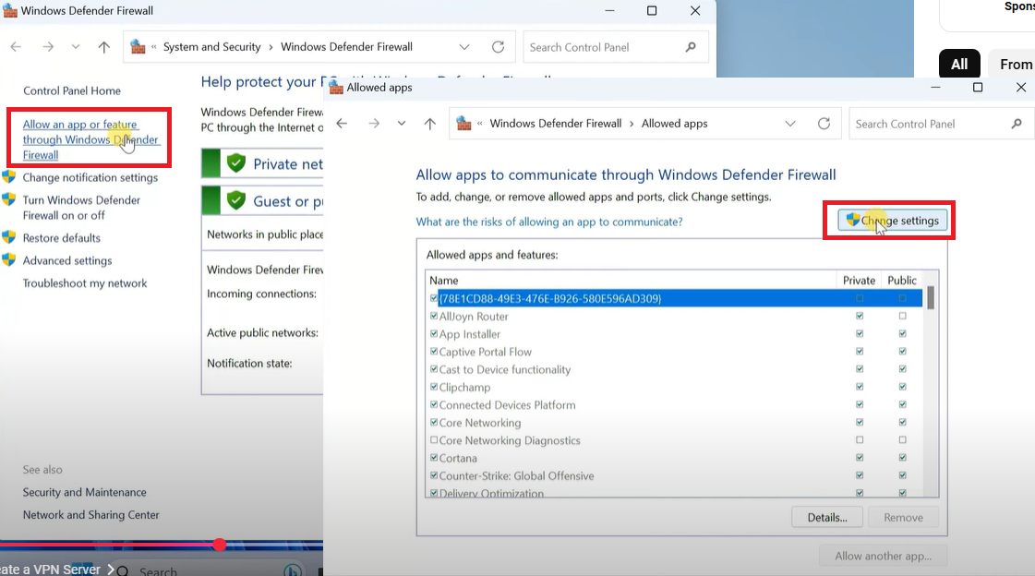
Turn On Private & Public
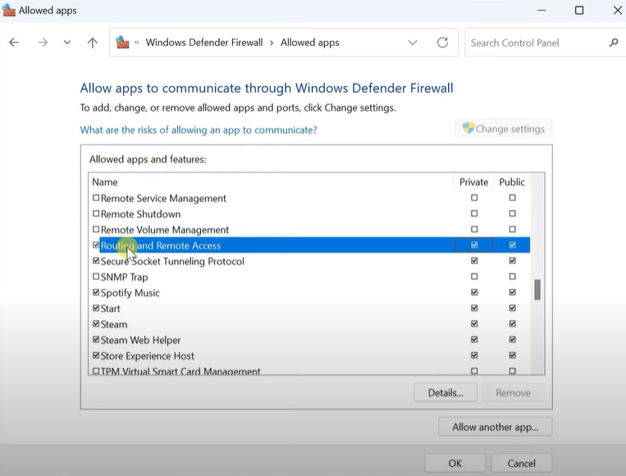

Port Forward VPN Port to The Server IP / Hostname
XXXX.dyndns.info or Ip Address

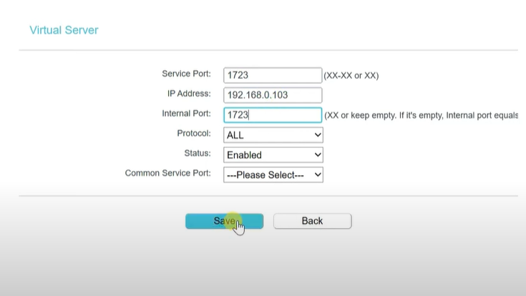

Allow/Enable in Security tab PPTP if exists in the router :
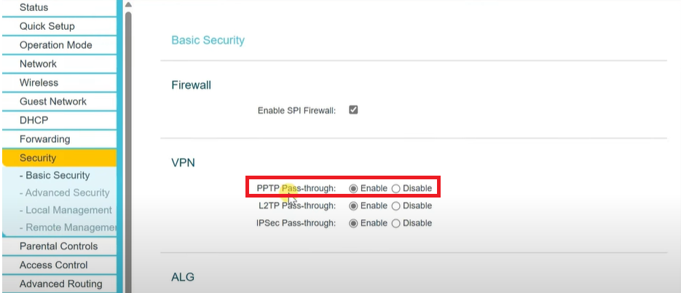

New Incomming Connection has been created to allow the Vpn users to connect
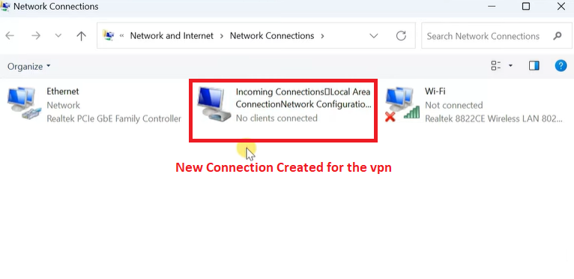

CONNECT TO VPN SERVER

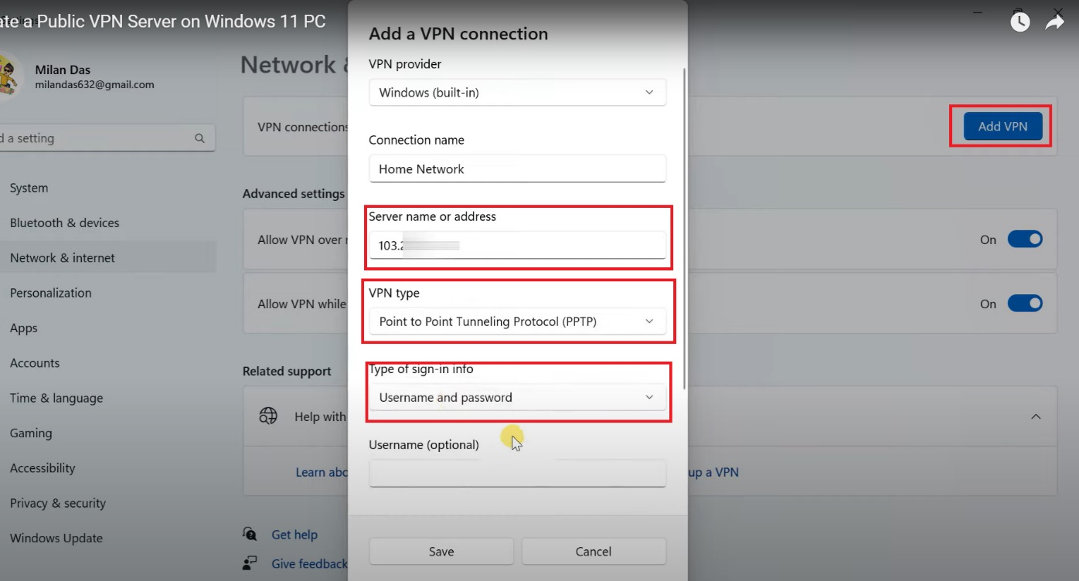
You add the username and the password that has been created in the vpn server, once saved you can connect to the VPN and disconnect whenever needed.

